**DAILY ONLINE ACTIVITIES SUMMARY**

|  |  |  |  |  |  |  |  |  |
| --- | --- | --- | --- | --- | --- | --- | --- | --- |
| **Date:** | **22-05-2020** | | | | | **Name:** | **Deril Quadras** | |
| **Sem & Sec** | **8 A** | | | | | **USN:** | **4AL16CS031** | |
| **Online Test Summary** | | | | | | | | |
| **Subject** | | **SMS** | | | | | | |
| **Max. Marks** | | **40** | | **Score** | | | **27** | |
| **Certification Course Summary** | | | | | | | | |
| **Course** | **Introduction to EC2 Auto scaling.** | | | | | | | |
| **Certificate Provider** | | | **AWS** | | **Duration** | | | **10 mins** |
| **Coding Challenges** | | | | | | | | |
| **Problem Statement:**   1. **Write a c program to implement various operations of singly linked list stack** | | | | | | | | |
| **Status: Solved** | | | | | | | | |
| **Uploaded the report in Github** | | | | | **Yes** | | | |
| **If yes Repository name** | | | | | **Derilquadras/online_c_coding_repository** | | | |
| **Uploaded the report in slack** | | | | | **Yes** | | | |

Online Test Details: (Attach the snapshot and briefly write the report for the same)



Certification Course Details: (Attach the snapshot and briefly write the report for the same)

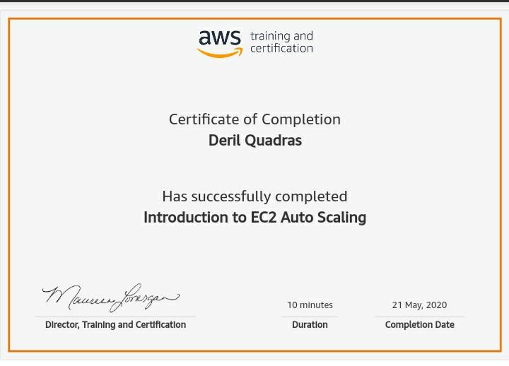

Coding Challenges Details: (Attach the snapshot and briefly write the report for the same)

**PROGRAM 1 .**

**//Write a c program to implement various operations of singly linked list stack**

**#include <stdio.h>**

**#include <stdlib.h>**

**struct node**

**{**

**int info;**

**struct node *ptr;**

**}*top,*top1,*temp;**

**int topelement();**

**void push(int data);**

**void pop();**

**void empty();**

**void display();**

**void destroy();**

**void stack_count();**

**void create();**

**int count = 0;**

**void main()**

**{**

**int no, ch, e;**

**printf("\n 1 - Push");**

**printf("\n 2 - Pop");**

**printf("\n 3 - Top");**

**printf("\n 4 - Empty");**

**printf("\n 5 - Exit");**

**printf("\n 6 - Dipslay");**

**printf("\n 7 - Stack Count");**

**printf("\n 8 - Destroy stack");**

**create();**

**while (1)**

**{**

**printf("\n Enter choice : ");**

**scanf("%d", &ch);**

**switch (ch)**

**{**

**case 1:**

**printf("Enter data : ");**

**scanf("%d", &no);**

**push(no);**

**break;**

**case 2:**

**pop();**

**break;**

**case 3:**

**if (top == NULL)**

**printf("No elements in stack");**

**else**

**{**

**e = topelement();**

**printf("\n Top element : %d", e);**

**}**

**break;**

**case 4:**

**empty();**

**break;**

**case 5:**

**exit(0);**

**case 6:**

**display();**

**break;**

**case 7:**

**stack_count();**

**break;**

**case 8:**

**destroy();**

**break;**

**default :**

**printf(" Wrong choice, Please enter correct choice ");**

**break;**

**}**

**}**

**}**

**void create()**

**{**

**top = NULL;**

**}**

**/* Count stack elements */**

**void stack_count()**

**{**

**printf("\n No. of elements in stack : %d", count);**

**}**

**/* Push data into stack */**

**void push(int data)**

**{**

**if (top == NULL)**

**{**

**top =(struct node )malloc(1sizeof(struct node));**

**top->ptr = NULL;**

**top->info = data;**

**}**

**else**

**{**

**temp =(struct node )malloc(1sizeof(struct node));**

**temp->ptr = top;**

**temp->info = data;**

**top = temp;**

**}**

**count++;**

**}**

**/* Display stack elements */**

**void display()**

**{**

**top1 = top;**

**if (top1 == NULL)**

**{**

**printf("Stack is empty");**

**return;**

**}**

**while (top1 != NULL)**

**{**

**printf("%d ", top1->info);**

**top1 = top1->ptr;**

**}**

**}**

**/* Pop Operation on stack */**

**void pop()**

**{**

**top1 = top;**

**if (top1 == NULL)**

**{**

**printf("\n Error : Trying to pop from empty stack");**

**return;**

**}**

**else**

**top1 = top1->ptr;**

**printf("\n Popped value : %d", top->info);**

**free(top);**

**top = top1;**

**count--;**

**}**

**/* Return top element */**

**int topelement()**

**{**

**return(top->info);**

**}**

**/* Check if stack is empty or not */**

**void empty()**

**{**

**if (top == NULL)**

**printf("\n Stack is empty");**

**else**

**printf("\n Stack is not empty with %d elements", count);**

**}**

**/* Destroy entire stack */**

**void destroy()**

**{**

**top1 = top;**

**while (top1 != NULL)**

**{**

**top1 = top->ptr;**

**free(top);**

**top = top1;**

**top1 = top1->ptr;**

**}**

**free(top1);**

**top = NULL;**

**printf("\n All stack elements destroyed");**

**count = 0;**

**}**